

Lawyer Finding System

**User Manual**



**Supervised by**

Rezvi Shahariar

Assistant Professor

Institute of Information Technology

University of Dhaka

**Submitted by**

Sazidul Islam

Roll: BSSE 0633



## Introduction

A user guide also commonly known as a user manual, is a technical communication document intended to give assistance to people using a particular system. It is usually written by a technical writer. Although user guides are written by programmers, product or project managers, or other technical staff particularly in smaller companies. User guides are most commonly associated with electronic goods, computer hardware and software. Most user guides contain both a written guide and the associated images. In the case of computer applications, it is customary to include screenshots of the human-machine interface.

## Home Page:

This is the home page. Here a normal user can search any law related question and can add any question. There is also sign in and sign up button for lawyer authentication. For normal user there is need appointment button for authentication.

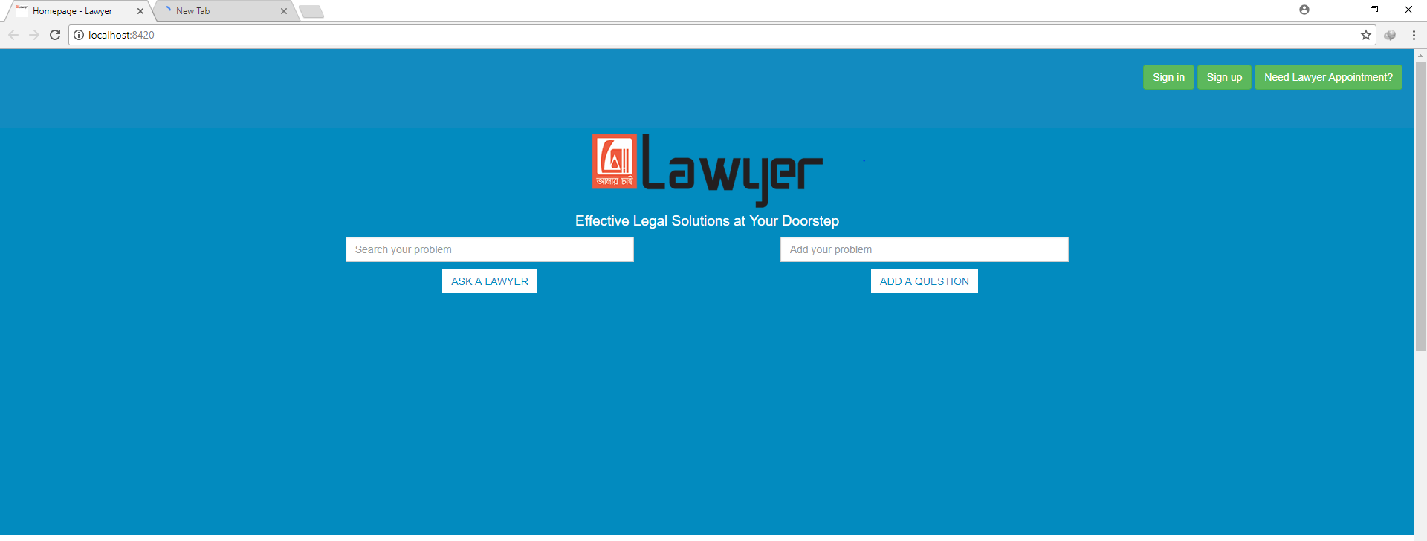

In home page there is also Search by category button, when a user click on this a modal opens with different types of law category. When they select any the searching result will be shown based on this selection.

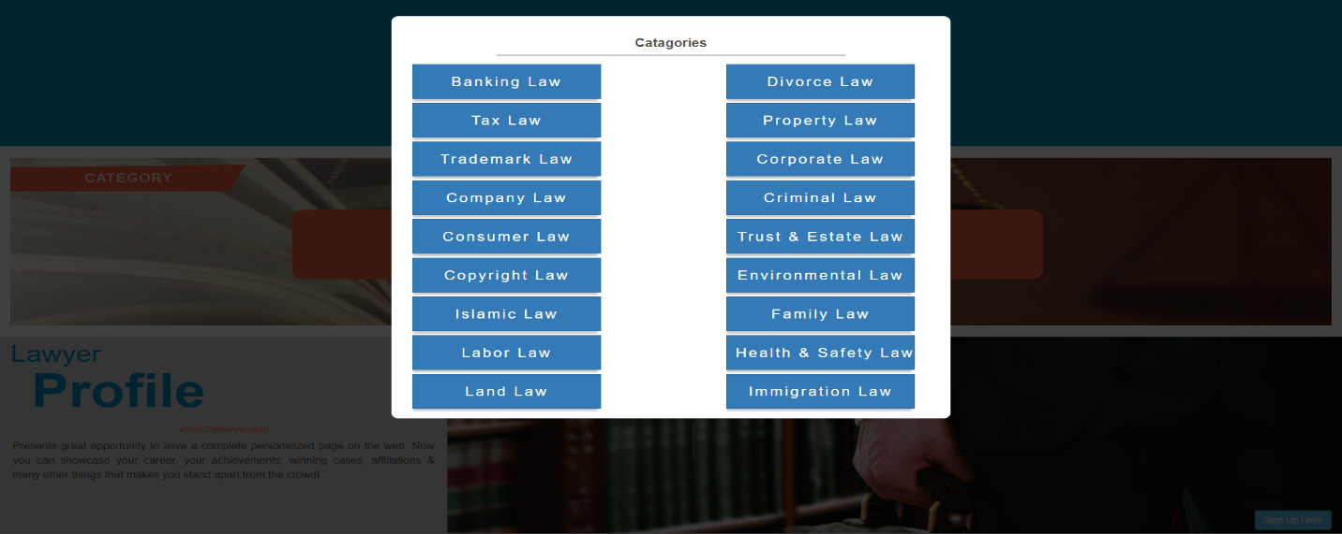

User can also search lawyer based on area button with different location. There is also a button for knowing the legal rights.

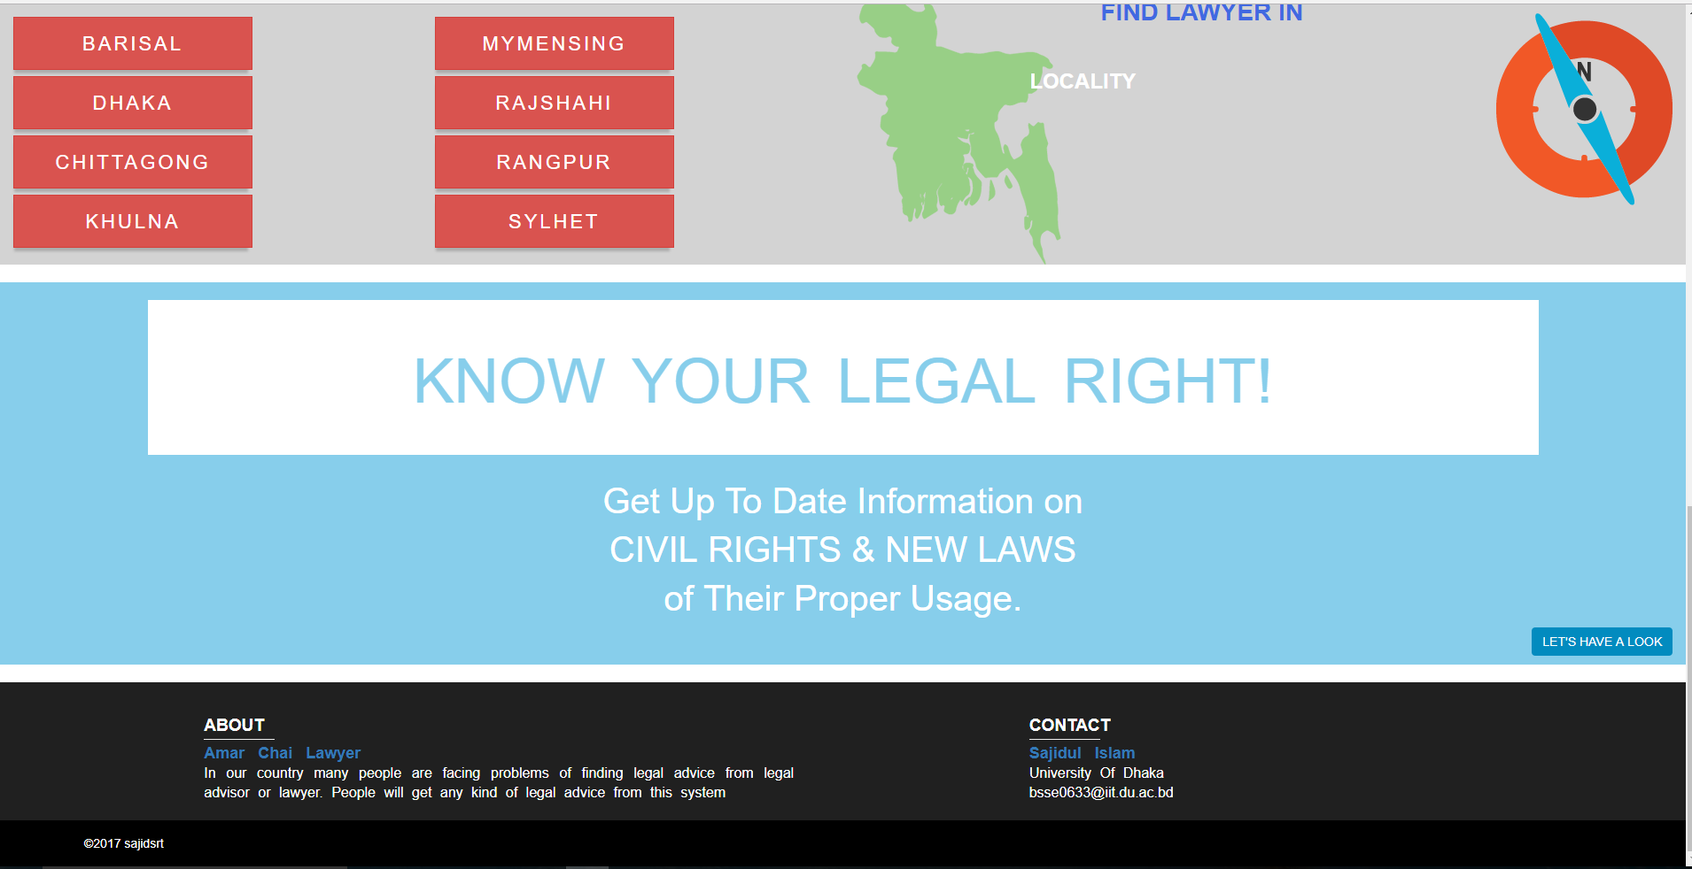

## Lawyer sign in page:

This is the sign in page for lawyer. After login user will go to his/her profile page.

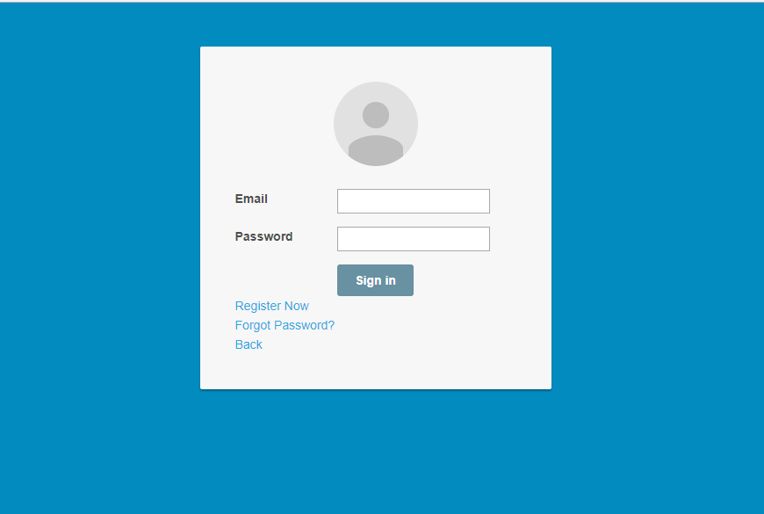

## Lawyer Registration page:

Lawyers have to give input of these fields to complete registration for this system.

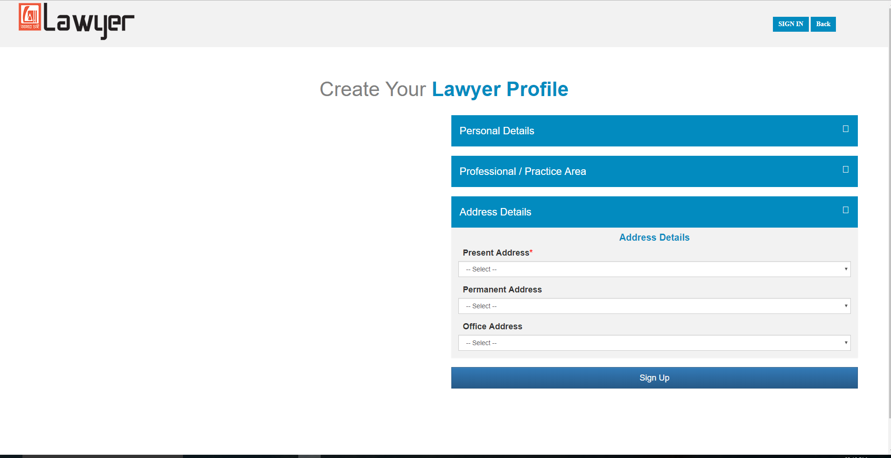

## Lawyer Profile Page:

After successful login a lawyer will redirected to his profile page. Profile page will contain the information that were given during registration.

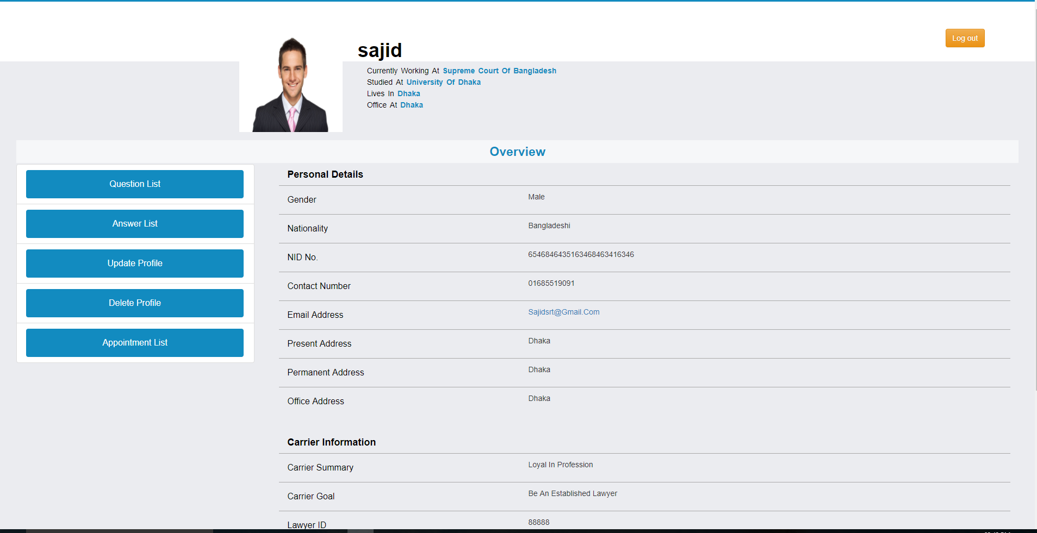

## Update Lawyer Page:

A lawyer can update any type of information which he/she had given during registration.

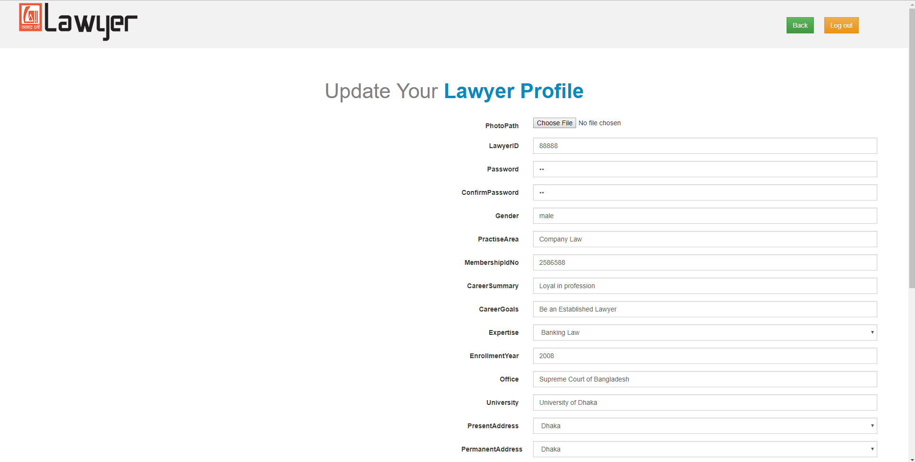

## Delete Lawyer Profile:

A lawyer can delete his account any time.

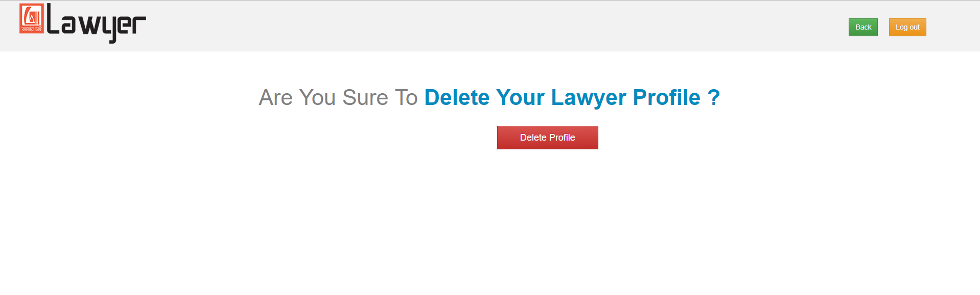

## Question List Page:

From lawyer profile he/she can see the question list added by the users.

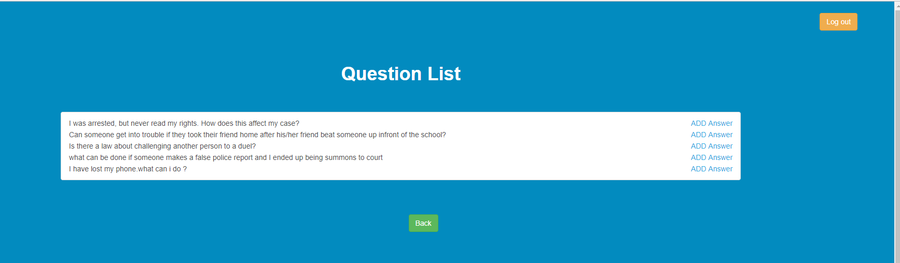

## Add Answer Page:

A lawyer can add an answer of a question clicking on this question.

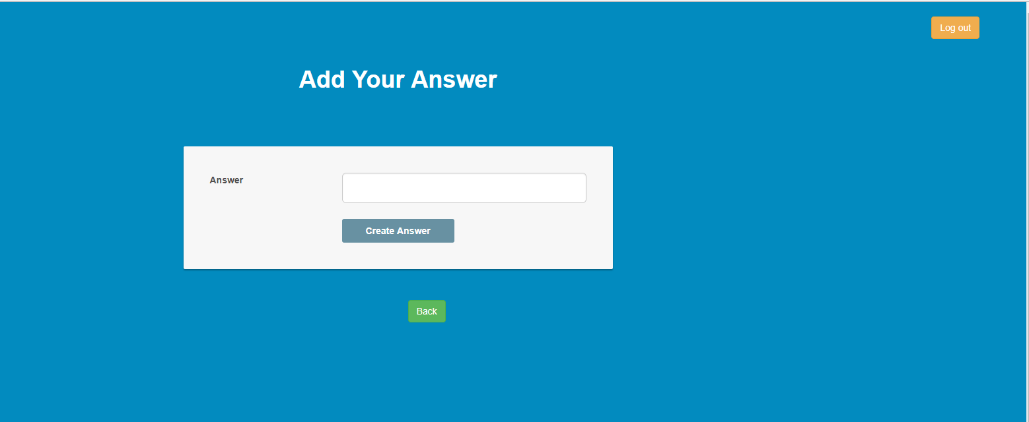

## Answer List Page:

From lawyer profile he/she can see the answer list added by him/her.

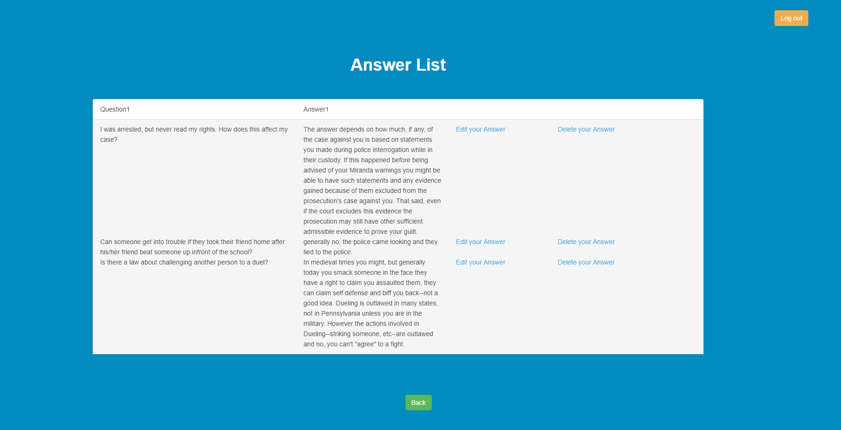

## Edit Answer Page:

From Answer list page a lawyer can edit his question by clicking the edit button.

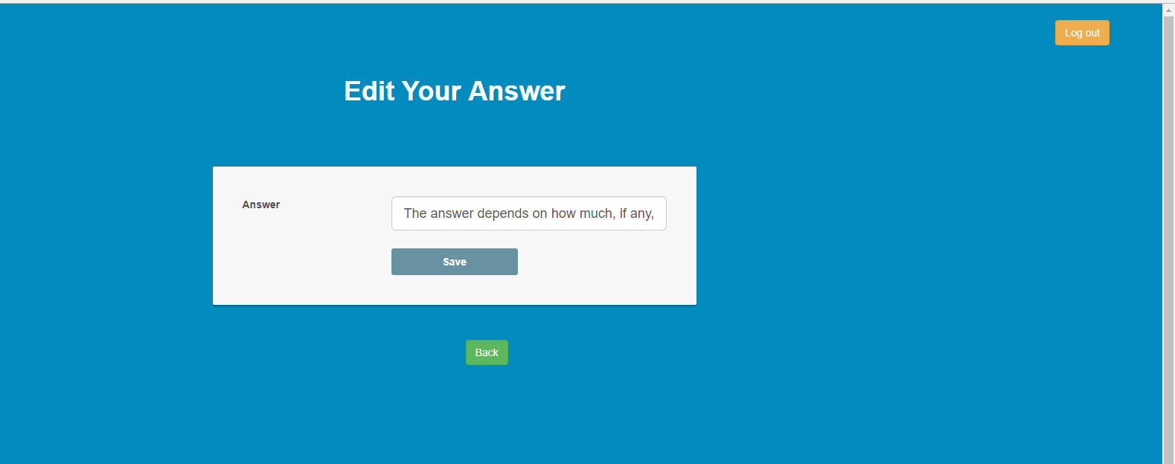

## Delete Answer:

A lawyer can able to delete his given answer by clicking delete link from answer list page.

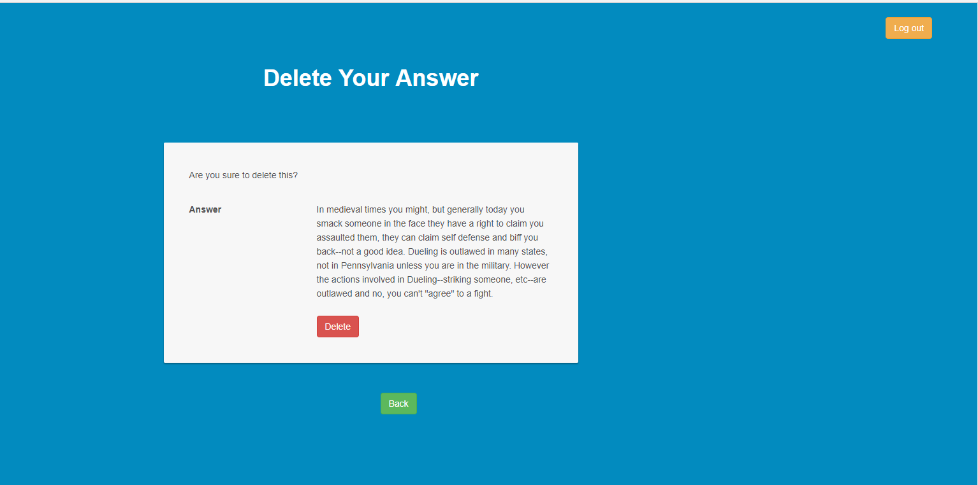

## Appointment List for Lawyer Page:

From lawyer profile he/she can see the Appointment Request list for him/her.

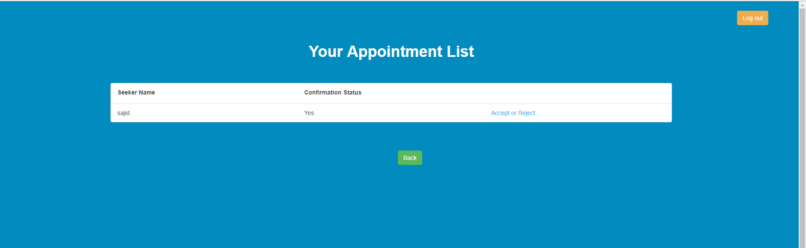

## Appointment Confirmation by Lawyer Page:

A lawyer can reject or accept any appointment request. If he accept this the user will see the contact details of him otherwise not.

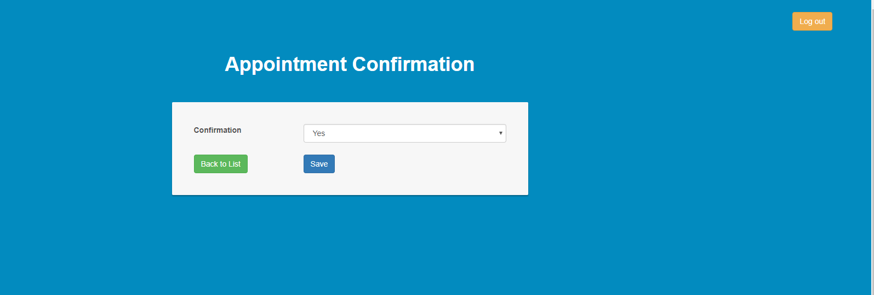

## Registration Page for Normal User:

A normal user who need who needs to get appointment from lawyer should be authenticated into the system. This is the registration page for a normal user.

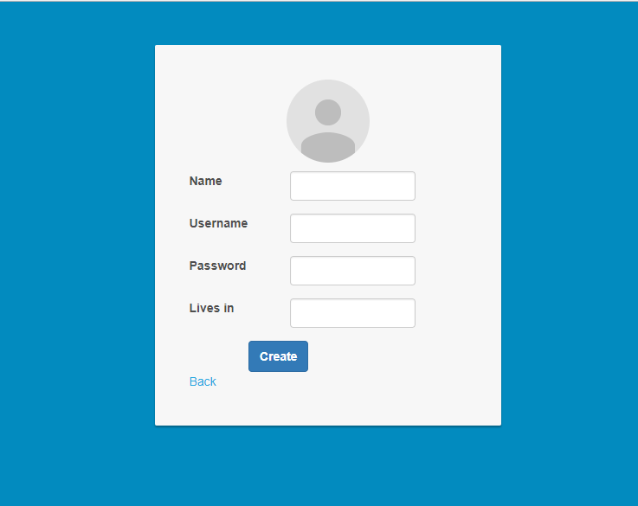

## Sign in page for normal user:

To send appointment request, he/she need to logged in into the system.

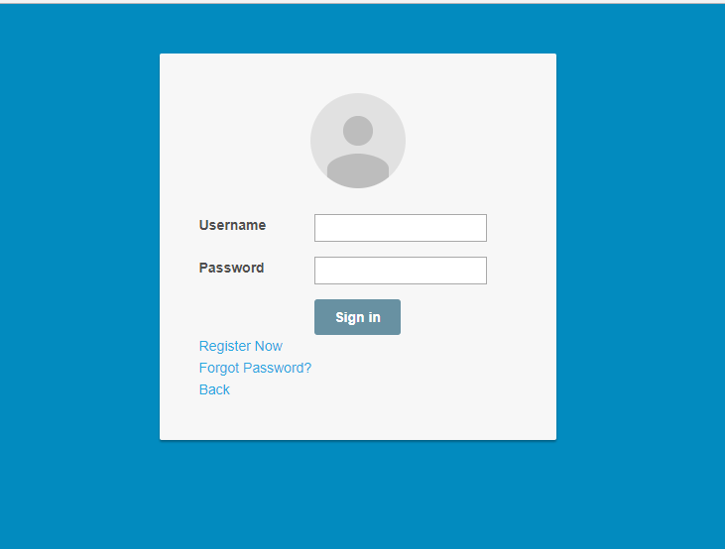

## Profile Page for Normal User:

After login, the normal user will redirect to his/her profile page.

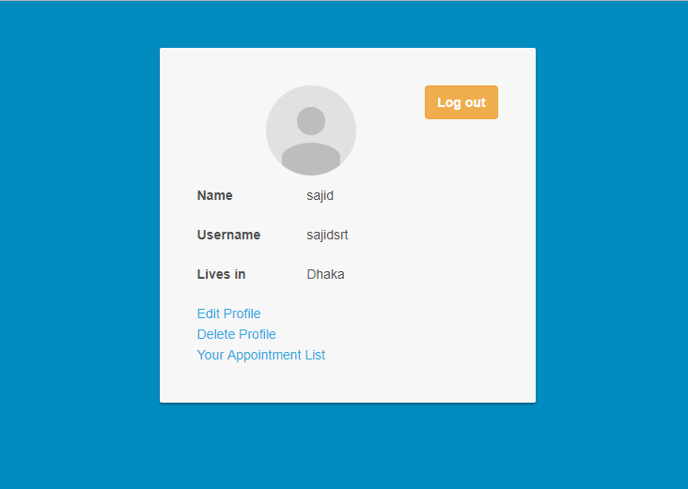

## Edit Profile Page for Normal User:

A normal user can edit his information at any time.

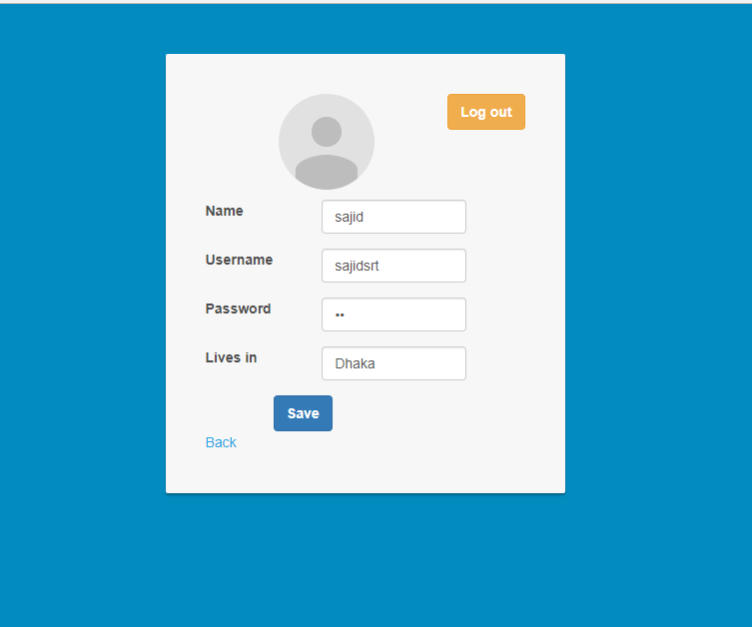

## Delete Account Page for Normal User:

A normal user can delete his account any time.

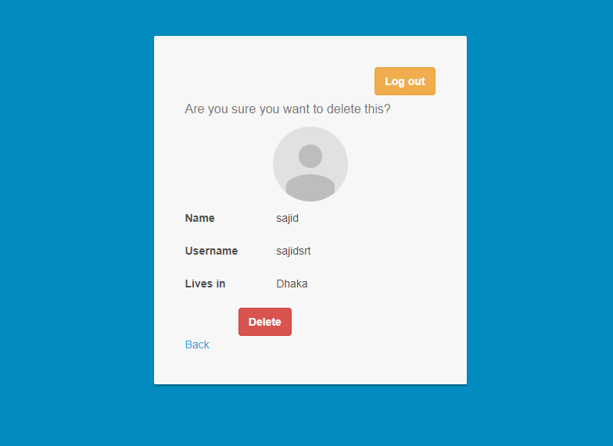

## Appointment Request List Page for Normal User:

User can see the list of his/her lawyer appointment request list by clicking appointment list link from profile page.

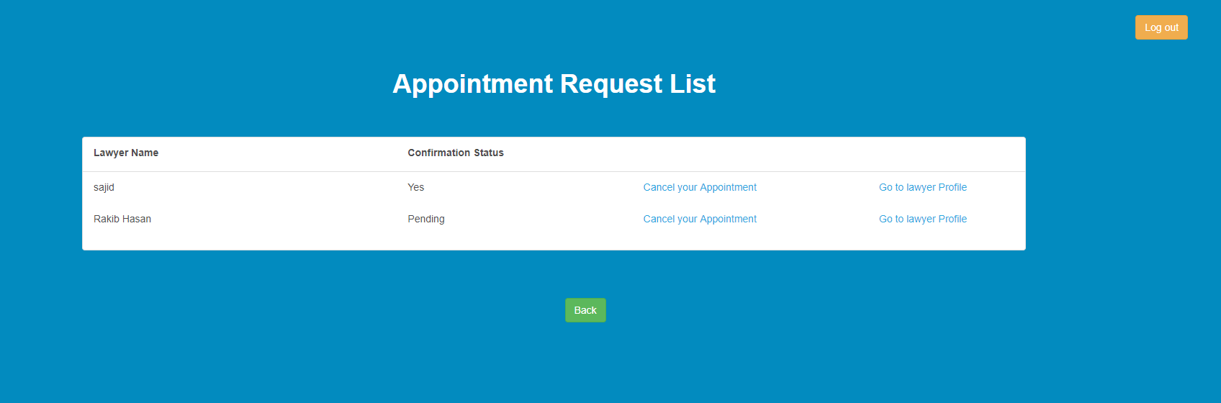

## Appointment Confirmation Page for Normal User:

User can cancel his appointment request any time.

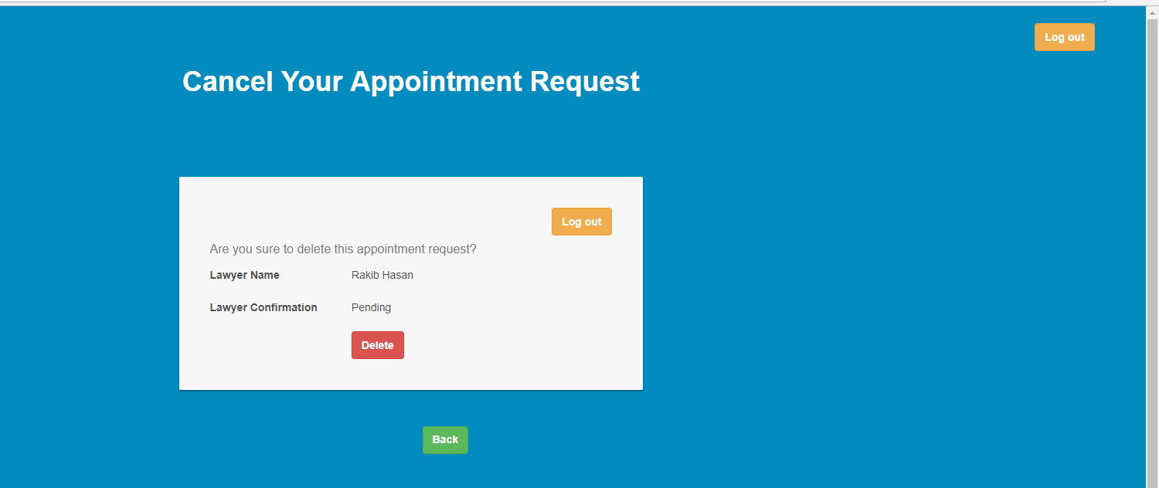

## Lawyer Search by Category:

User can search lawyer by law category. After selecting any category the search list will be shown.

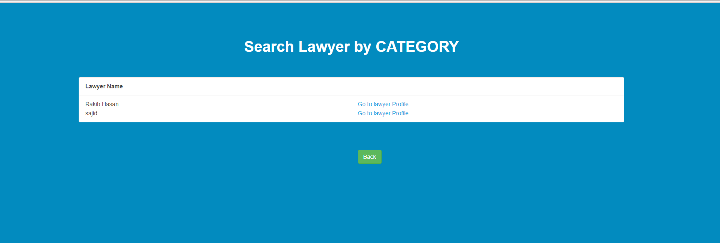

## Lawyer Search by Area:

User can search lawyer by area. After selecting any location, the search list will be shown.

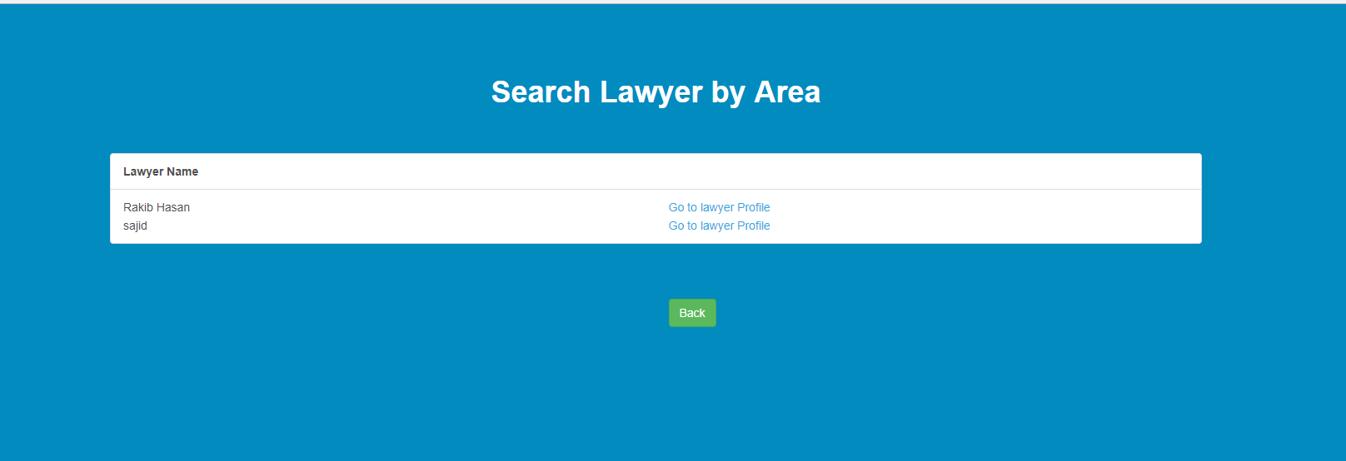

## Lawyer Public Profile Page For appointment request accepted page:

This is the public profile page of lawyer to the users which appointment requests are accepted by him.

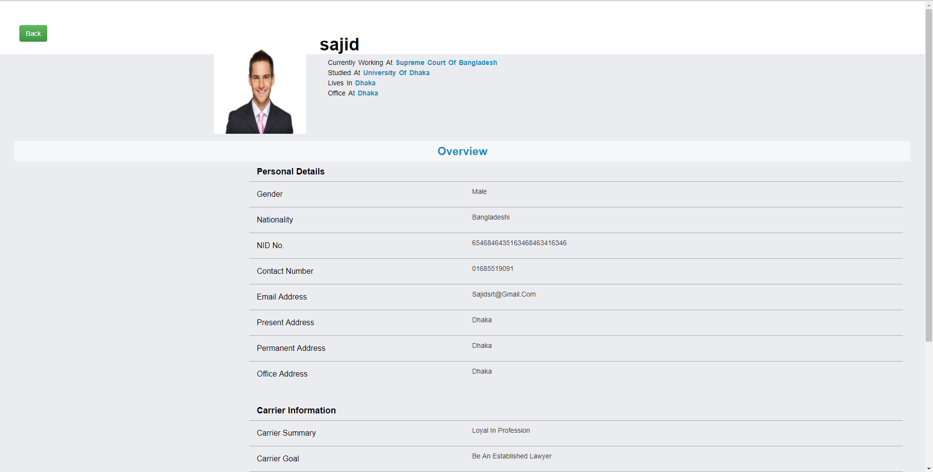

## Lawyer Public Profile Page For appointment request rejected page:

This is the public profile page of lawyer to the users which appointment requests are rejected by him.

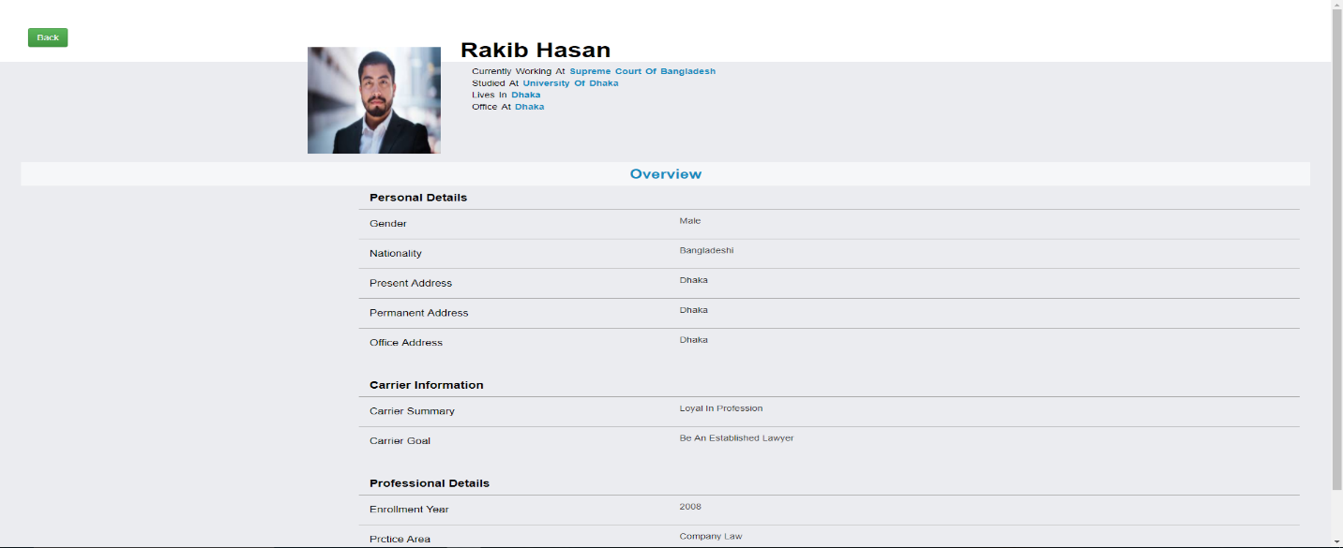

## Lawyer Public Profile Page For request appointment page:

This is the public profile page of lawyer. From this page the normal user can send appointment request to the corresponding lawyer.

